- Write a java program to add the two numbers.
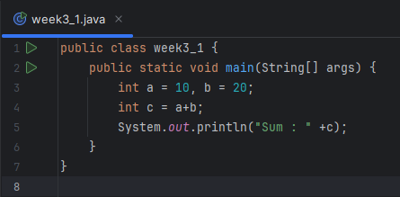
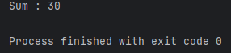
- Write a java program to multiply two floating numbers.
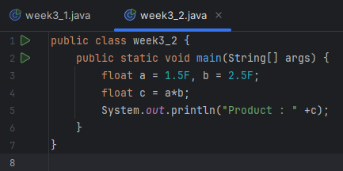
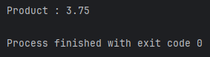
- Write a java program to display a cube of a number.
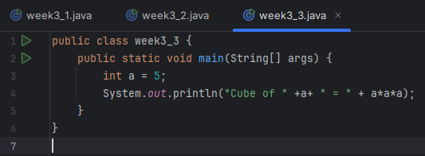
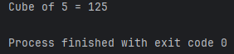
- Write a Java program that takes three numbers as input to calculate and print the average of the numbers.
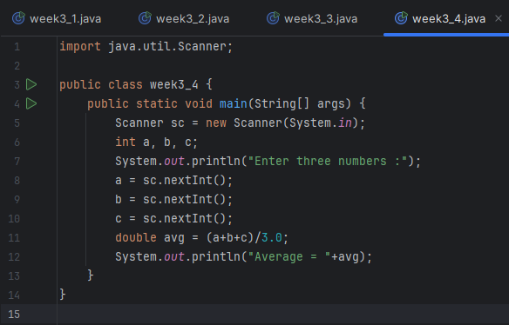
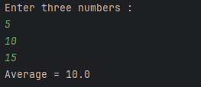
- Write a Java program to compute the distance between two points.
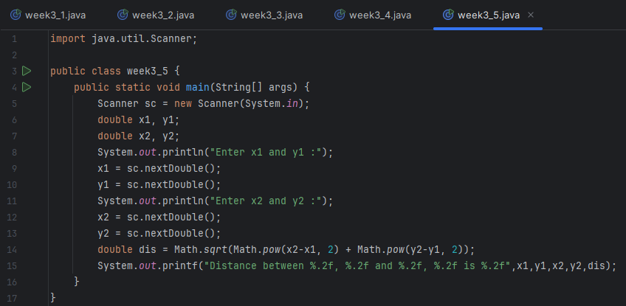
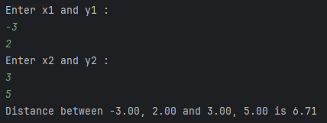
- Write a Java program to swap two numbers using a temporary variable.
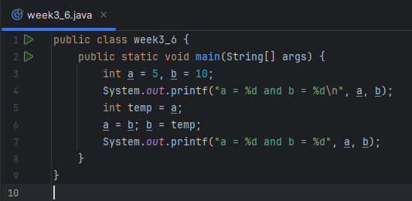
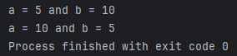
- Write a Java program to calculate the area of a rectangle given its length and breadth.
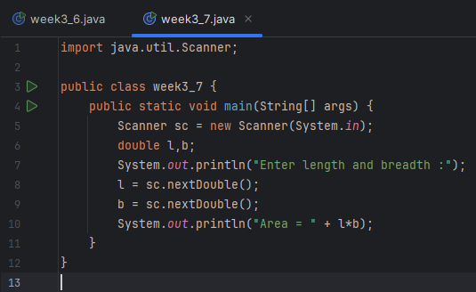
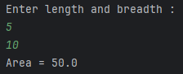
- Write a Java program to convert temperature from Celsius to Fahrenheit.
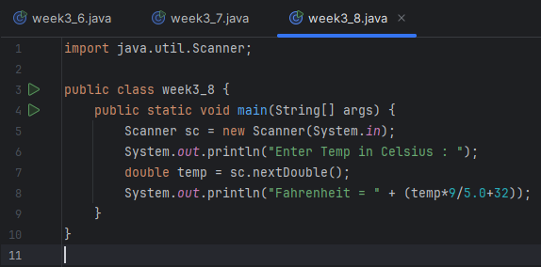
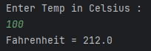
- Write a Java program that takes two integer inputs and computes their remainder and quotient.
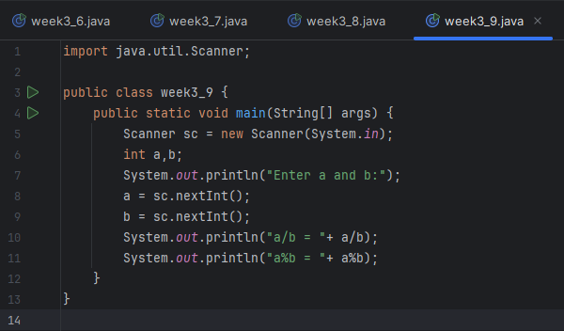
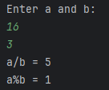
- Write a Java program to find the circumference of a circle given its radius.
